For the first step of the lab, I was required to connect to the database that I created and named in module one. This action was accomplished by entering the command ‘mysql> use Pirrone;’.

For the second and third steps of the lab, I was required to create two new tables in my database named Employee and Branches. To accomplish this, I entered the following code that was given in the instructions:

‘CREATE TABLE   Employee (

Employee_ID   SMALLINT,

First_Name    VARCHAR(40),

Last_Name   VARCHAR(60),

Department_ID   SMALLINT,

Classification   VARCHAR(10),

STATUS   VARCHAR(10),

Salary   DECIMAL(7,2));

‘CREATE TABLE Branches (

Department_ID SMALLINT,

Department_Name VARCHAR(50));

The Branches code that was given was not complete, so I altered it as seen above. These commands created the tables Employee and Branches with several categories and allowed them to accept certain data inputs like characters, decimals, and integers. The screenshot above shows my tables outputs by entering ‘describe Employee;’ and ‘describe Branches;’.

For the next part, I was tasked with inserting into the Employee table several parameters for various employees. This was accomplished using the code that is seen in the picture (INSERT INTO Employee VALUES(various parameters);). I then used the command ‘select * from Employee;’ to display my updated table now filled in with employees and their associated information.

The next step had me insert two more employees and myself into the Employee table, without assistance. I used the above code to accomplish this task and viewed it using the same command I used in the previous step.

The next part had me add a musician, athlete, or another famous character to the table. As seen above, I added infamous actor and internet sensation Pedro Pascal to my Employee table, with applicable information as required by the lab guidelines.

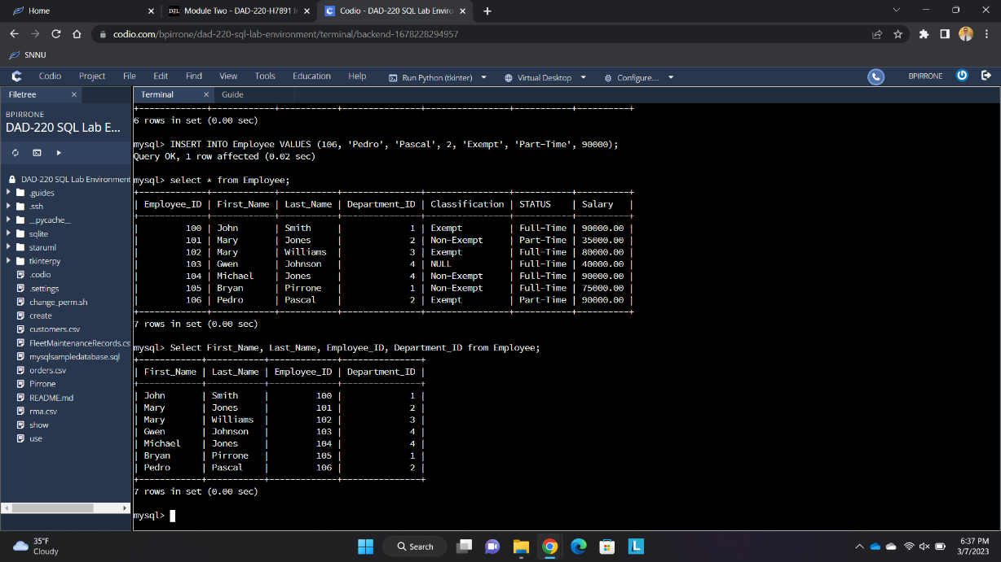

The last step had me display only several parameters from my Employee table: First_Name, Last_Name, Employee_ID, and Department_ID. In order to accomplish this, I enter the code seen above to only display the parameters that I requested from the Employee table.